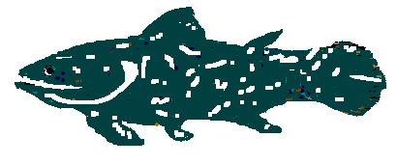

MAY 2011

A long awaited Newsletter. We hope you are all well and keeping warm. You have received the Emails with all the exciting news about Oudtshoorn Champs. I am sure it is still in the mind of most of us, especially the first-timers, who were Bruce Rankin, Leonard Langenhoven, Denise Collignon, Monica Hefer, Arno Spies, Rardi Skea, Linda Packwood, Ingrid Landman and Alexis Homveld. We had a wonderful time and would like to thank Jill Black and team again, for staging such an memorable event.

AGM
The Coelacanth and Tshwane AGM’s were held at the Warrant Officers Mess, Valhalla. 34 members, friends and families attended. Thank you to Craig for organising the venue. We sat at tables with snacks. Drinks were available from the bar at reasonable prices. We had a great meal once the meetings were over. We will definitely do the same again next year and hope to see more members attending.
Rita Burger was appointed as an additional member to Coelacanth committee.
David Arbuthnot was appointed Treasurer and Anton Harrop-Allin appointed Vice President, onto the Tshwane Committee. Thank you for volunteering. We welcome you and will really appreciate your input and help in the future.
The minutes of the Coelacanth AGM have been sent out and Tshwane minutes will follow shortly

Issues of Importance Discussed at the AGM:
These issues are covered in the Tshwane Minutes.
Just to hightlight a few points.
Registration and Fees:
Unfortrunately our fees are not yet available. SSA have come up with a new requirement, that Masters Clubs must affiliate to Regional Aquatic Associations.
While we fully support NTS, it makes no sense to affilicate to them: Why?
Coelacanth/Tshwane need to provide Masters Galas according to the spirit and rules of Masters. This is required by Fina, as World Masters Records may only be broken at a Masters Gala. SAMS have taken this matter up with SSA and we will keep you informed.
SA Masters Records:
It was agreed that SA Masters Records would only be recognised if broken at a Masters Gala as per above.
SA Masters Records broken by Non-South African Citizens.
The majority of members agreed that non-South Africans should not be allowed to hold South African Masters Records
Open Water Swim Colours Qualifying Events:
As already being agreed and constituted events open to the general public, as well as Masters only events must be considered for SAMS Open Water Swimming Colours.
SAMS Open Water Colours Requirements
It is constituted that one has to attend 3 Nationals to acquire colours.
It was voted on at the AGM that this should be changed – that one has to be a member of a club for 3 years and not have to attend 3 Nationals.
Participation in Senior National Pool or Open Water events:
You need to be a member of a NTS club, and to meet all the NTS requirements, to be able to participate.

These above issues will be discussed at the Presidents Meeting in Cape Town on 28th May, 2011.

Coelacanth Awards:
Best Male Swimmer: Leonard Langenhoven.
Best Female Swimmer: Sabine Verryn.
Chariots of Fire: Ann Hanson.
Spirit Trophy: Sarel Theron.
Victor Ludorum 50+: Derek fyfe.
Victrix Ludorum 50+ Vilma Grobler and Greta Wallace.
Victor Ludorum 49-: Hendrik Thompson and Christoff Kok.
Victrix Ludorum 49-: Chane Vorster.

Tshwane Awards:
Best Male Swimmer: Leonard Langenhoven.
Best Female Swimmer: Sabine Verryn.
Most Improved Swimmer: Neville Muir
Excellent Progress in Swimming: Rita Burger
Most Enthusiastic Member: Hendrik Thompson
Swimmer of the Year: Kim Foster.

Congratulations to you all.
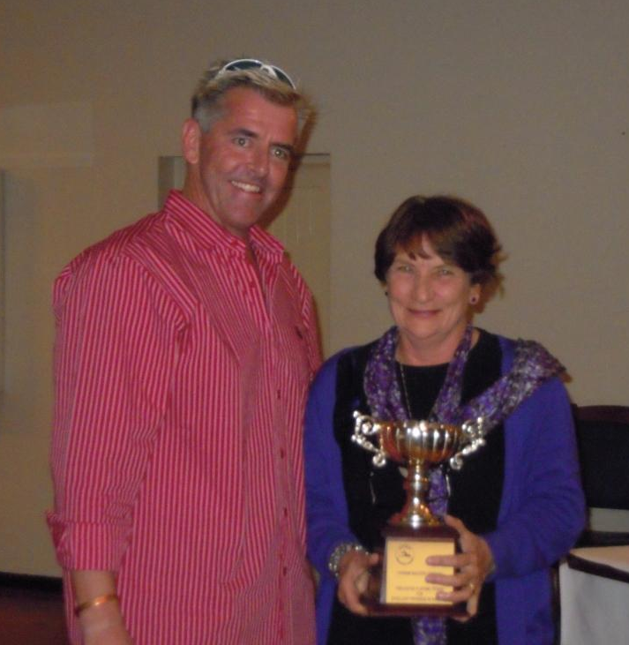
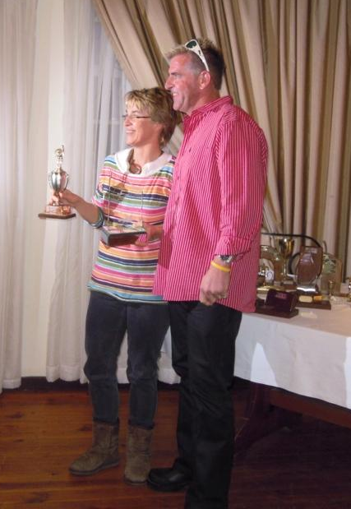
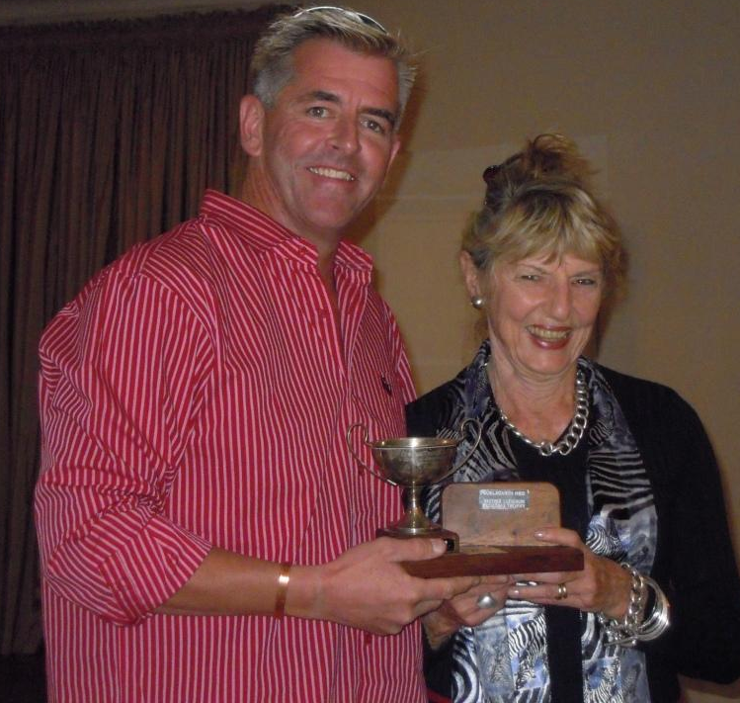
Craig and Vilma Grobler
Sabine Verryn Rita Burger

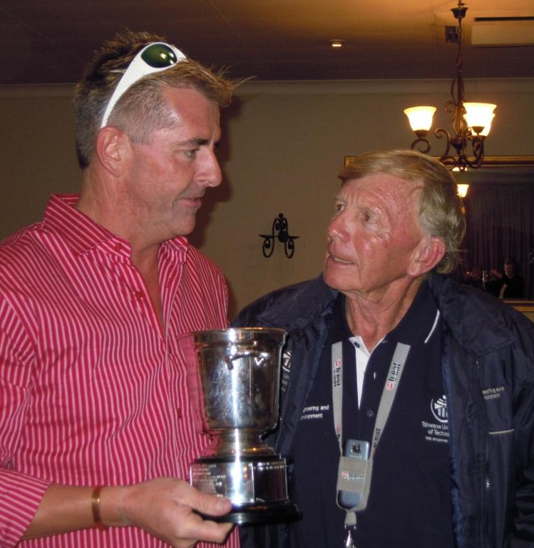
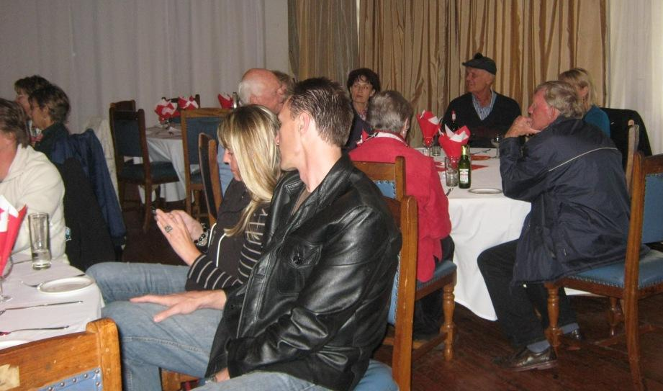

AGM Venue
Neville Muir

CLUB CAPTAINS FOR 2011/2012: Rita and Francois Burger

Present and Upcoming Events:

Polar Bear Challenge: www.hatfieldscs.co.za
Contact Jade Homveld 012 348 2970.
Jade Email: jhomveld@hatfieldcs.co.za
The first challenge took place on the 14th May. The second challenge on 18th June, 2011, and the third challenge will take place on the 23rd July, 2011.
Venue: Hatfield Christian School, Pretoria.
Frostbite Gala 2:
The first frostbite Gala took place on 14th May. 2011 at Wahoo Pool, Sunninghill.
The second Frostbite Gala will be on the 18th June, 2011, also at Wahoo Pool.
Entry form will be sent out as soon as we receive it.
Sop, Swem and Sherrie:
This will take place in Bloemfontein, hosted by Free State Masters.
It is a great fun event and was well supported by Coelacanth last year.
Accommodation for this event. We all stayed together last year at:
Scholtz Guest House.
051 5222611 or 051 5225874 - contact Kieppie.
Single R240, 2 bed R260, 3 beds R320, Double R260 or R280.
Please contact him soon to provisionally book.
Date: 30th July, 2011. Entry form to follow shortly.
SAMS Winter Challenge:
Date: August 13th, 2011
Hillcrest Pool. Time: 10h00to 13h00. Anyone may enter, friends and family are welcome. You may swim as far as you like in 1 hour. You receive a gift later in the year from SAMS. Entry forms will be sent out end of June.
Coelacanth 1500 Swim:
Date: 8th October, 2011,
Hillcrest Pool. Time 8h00 to 13h00.
This event is well supported by Gauteng Masters, Easterns and Tshwane.
Non members are welcome, over 19. Masters members children may also take part.
Inter-Regional Gala:
Date: 12th November, 2011.
Hillcrest Pool. Time 13h00 to 18h00
This is a great event, with a free braai afterwards at the pool, organised by Tshwane members for all.

The Gala Schedule showing both Tshwane and Gauteng dates and venues, and will be sent to all once completed.

Social Events:
A night out on the town has been organised by Kim Foster to attend a supper at Ocean Basket Menlyn on the 4th June, 2011. Please reply to Joyce 08274751560 or 012 667 4247 before the 2nd of June, 2011 if you able to attend.

Rietvlei Midyear Braai:
This will be on Saturday 16th July. Come as early as you like to this beautiful Reserve and spot the rhinos, zebras, buffalo etc and a number of species of buck and birds. Fires will be lit around 12.30pm.

CLUB NIGHTS AT D.S.G. St Marys School for Girls, Duxbury Road, Hatfield.
Every Tuesday at 17h00 onwards we get together and do some training.
It has been well supported last season with nearly every lane busy. The pool was in excellent condition and the water warm (heated).
Please we would like the braai nights to be better supported. These are held every 1st Tuesday of the month at the school pool. It is a time to catch up with all the news and to socialize with everyone. Opening Braai/club night 6th Sept, 2011.

KIT:
We still have some great bargains going on the kit list sent out recently.
Unfotunately we will be changing our colour cap for champs in Cape Town.
Free State also have the orange cap and it is difficult to follow our swimmers in the water at National events. We are also looking at getting really decent costumes this year through Jade.

BIRTHDAYS:
I have to apologise there are no months dates or names on this Newsletter.
All those who have had a birthday since the new Year and to those who are going to have a birthday soon in the future, we hope you had and are going to have, a super day!

CAPE TOWN NATIONALS 2012
Will take place from 14-17 March, 2012 at University of the Western Cape.
Accommodation list has already been sent out to all Coelacanths .

WELL-WISHES
To all those who have not been well or had operations etc. We hope that you recover soon. Derek has just had another op. on his wrist, broken again in a few places. He now has screws and bolts to keep all in place. Get better soon Derek!

