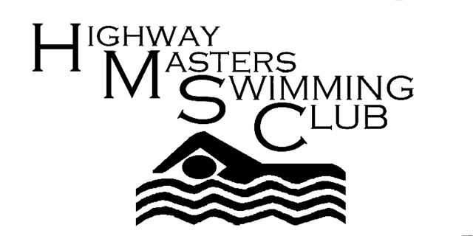

Highway Masters Swimming Club Newsletter November 9th 2011
Greetings to all Highway Swimmers
SAMS Short Course Championships
It was great to see such a good turnout of Highway swimmers at the SAMS Short course Championships on 30th October. Many records were broken, some that had stood for nearly 20 years and others for only a month. (Debbie the challenge is on!)
If there was any member who entered when the gala was scheduled for 23rd October and was then re scheduled for 30th October and you could not attend, please contact Sven Dahlmann, KZN Masters swimming treasurer. He will refund you your money. (Sven 084 6801112 or sven@wardellaccounting.co.za)
Lake Eland Swim
I believe at least four Highway swimmers went down to Lake Eland, South Coast to swim last Sunday. They were Mandy Koegelenberg, Sue Robinson, Bronwen Griffiths and Dawn Rode. Congratulations Mandy on winning the ladies 31yr to 40 yr. category. Please let me know whether there were others.
Long Course Gala
The next gala is on Sunday 13th November at Kings Park Pool at 9.30 for 10 am. Entry forms were sent out. Please fill in as the Committee are working on Pre-entries for galas now to make the galas run more smoothly. You will however be able to enter on the day at a cost of R20.00. If you are having difficulty filling in the form phone Peter Larcombe with the events that you wish to enter, your approximate times and your age category.(Peter 084 4100113)
Heather Goldstein has also entered some teams for the relays. Swimmers will be decided upon on the day.
No braais are allowed at Kings Park. Heather Goldstein has suggested that we should eat at Suncoast or at one of the restaurants at Moses Madhiba Stadium afterwards. The exact venue will be decided on the day. Contact Heather on 084 2064484 should you wish to stay for a light luncheon.
Highway is hosting the gala so we will need members/friends/ family to assist with time keeping at the gala.
Although KZN Masters Swimming Committee tries to encourage swimmers to attend galas it is often difficult due to distance, family commitments etc. You will still be able to attend KZN Champs and SA Champs provided you give Heather a letter stating why you were unable to attend the minimum number of galas.
Snippets
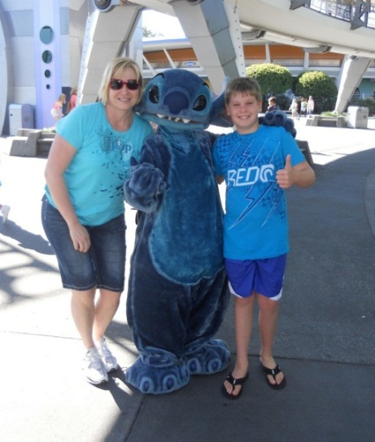
Debbie Nortjie (Wade) and her son Dante recently visited Disneyland in Orlando.
Maretha Heymans is doing three weeks voluntary work for the Israeli Army.
Ann Gray took part in the 36km OFM road cycle race last Sunday in Bloemfontein.

Open Water Swimming
For those who enjoy open water swimming and are aiming for SAMS qualifying times for 3km swims the following Swim South Africa sanctioned Open Water swims are coming up shortly in KZN:.
20th November: Albert Falls Dam 3km, 1000m and 500m Fun. (www.midmarmile.co.za)
4th December: Capital K at Midmar Dam 10km (3rd Dec) 3km, 1000m and 500m Fun (www.capital-k.co.za)
18th December: KZN Open Water Swimming Champs at Midmar Dam 5km, 1000m and 400m Fun (www.midmarmile.co.za)
Regards

Highway Masters Swimming Club Committee
Heather Goldstein 084 2064484 (Chairperson) Peta Harrison 0833251482(Treasurer) Ann Gray 082 8280401 (PRO and Newsletter) and Bev Shuttleworth 083 2345200 (Kit and Relays)

